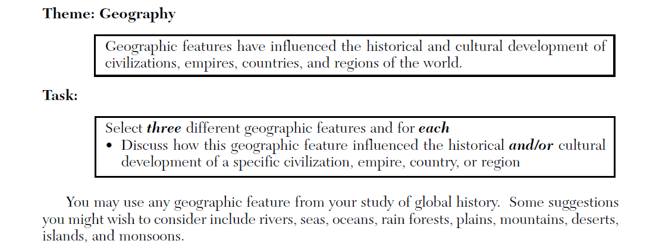
Thematic Essay One: Effects of Geography

Introduction: Throughout the course of history geographic features have influenced the historical and cultural development of cultures and societies across the world. The Tigris and Euphrates rivers in Mesopotamia, the Andes Mountain in the Inca Empires, and the abundance of natural resources such as coal and steel in England have been the key factors for determining the success and failures for their respective regions.
Geographic Feature One: Tigris and Euphrates river in Mesopotamia
Influence of Tigris and Euphrates Rivers in Mesopotamia | Effects of Geographic features in Mesopotamia
- The Tigris and Euphrates rivers influenced the development of Ancient Mesopotamia. This area is also known as the Fertile Crescent, because this land had rich soil and abundant crops, it was able to sustain an early civilization.  - The Tigris and Euphrates rivers flooded Mesopotamia at least once a year. As the floodwater receded, it left a thick bed of mud called silt. Farmers planted grain in this rich, new soil and irrigated the fields with river water. The results were large quantities of wheat and barley at harvest time. The surpluses from their harvests allowed villages to grow.  - One problem Mesopotamians or Sumerians faced was drought and extreme flooding.  - Over a long period of time, the people of Mesopotamia also known as Sumerians created solutions to deal with these problems.  - To provide water, they dug irrigation ditches that carried river water to their fields and allowed them to produce a surplus of crops.  - For defense, they built city walls with mud bricks.  - Sumerians traded their grain, cloth, and crafted tools with the peoples of the mountains and the desert. In exchange, they received raw materials such as stone, wood, and metal.  - These activities required organization, cooperation, and leadership. Leaders were needed to plan the projects and supervise the digging. These projects also created a need for laws to settle disputes over how land and water would be distributed. These leaders and laws were the beginning of organized government, religion —and eventually of civilization. | - The river system in Mesopotamia affected the way they viewed the world. The unpredictable flooding and little rain led to frequent famine which convinced them to believe supernatural forces controlled the world. Therefore, idea of religion was formed. In Mesopotamia people looked to religion to answer questions about life. They believed that powerful Gods and Goddesses controlled all aspects of human life. They believed in many gods and their religion was polytheistic. The most prominent building in a Sumerian city was the temple dedicated to the chief god or goddess of the city. This temple was often built atop a massive stepped tower called a ziggurat.  - With religion came the beginning of what we call social classes and government. Kings, landholders, and some priests made up the highest level in Sumerian society. Wealthy merchants ranked next. The vast majority of ordinary Sumerian people worked with their hands in fields and workshops. At the lowest level of Sumerian society were the slaves who worked as peasants. Social class affected the lives of both men and women. Sumerian women could work as merchants, farmers, or artisans. They could hold property in their own names. Women could also join the priesthood. Some upper-class women did learn to read and write, though Sumer’s written records mention few female scribes.  - Sumerians invented the wheel, the sail, and the plow and that they were among the first to use bronze. They were also the first to discover writing system named the cuneiform, mathematics, and geometry in order to erect city walls and buildings, plan irrigation systems, and survey flooded fields, Sumerians needed arithmetic and geometry. As a result, architectural innovations such as Arches, columns, ramps, and the pyramid shaped the design of the ziggurat and permanently influenced Mesopotamian civilization.

Geographic Features Two: Andes Mountain and Inca Empire.
Influence of Andes Mountain in Inca Empire. | Effects of Andes Mountain On Inca Empire
- The Inca Empire developed in the Andes Mountains of South America. The Incas had originally settled in a valley of the Andes Mountains around 1100. By 1400, the Inca began extending their rule across the Andes.  - Because the Incas lived in the mountains, they had no flat land for farming. They had to build wide step-like areas called terraces for farming. The Incas grew potatoes and other crops that could resist cold nights. They kept llamas and alpacas for their meat and wool, and to carry goods. Superb engineering skills allowed the Incans to construct vast stone buildings high in the Andes.  - The Incas built roads stretching over ten thousand miles to unite their vast empire. One Incan road was 2,500 miles long! In addition, the Incas built their capital – Cuzco – high in the mountains in present-day Peru. | - To control the huge empire, the rulers divided their territory and its people into manageable units, governed by a central administration. The Inca created an efficient economic system to support the empire and an extensive road system to tie it together. They also imposed a single official language, Quechua (KEHCH•wuh), and founded schools to teach Incan ways.  - To exercise control over their empire, the Inca built many cities in conquered areas. The architecture of government buildings was the same all over the empire, making the presence of the government apparent. All roads led to the capital, Cuzco. The heart of the Incan empire, Cuzco was a splendid city of temples, plazas, and palaces. In Inca Government, a chief led the people. The chief resided in Cuzco where the Incan ruler and his council of state held court. In general, local administration was left in the hands of local rulers, and villages were allowed to continue their traditional ways.  - The Inca had an ambitious public works program. The most spectacular project was the Incan road system. A marvel of engineering, this road system symbolized the power of the Incan state. The long network of roads and bridges spanned the empire, traversing rugged mountains and harsh deserts. The roads ranged from paved stone to simple paths. Along the roads, the Inca built guesthouses to provide shelter for weary travelers. A system of runners traveled these roads as a kind of postal service, carrying messages from one end of the empire to the other. The road system also allowed the easy movement of troops to bring control to areas of the empire where trouble might be brewing.
Geographic Feature Three: England and Industrial Revolution.
Influence of the Geographic Feature in England | Effects of Geographic Features in England
- Geography played an important role in shaping patterns of early industrialization in England. Availability of many key resources, such as coal, Iron, and mineral ores. Coal was the most important of these, since it was used in enormous quantities as a source of power. With abundant and easily mined coal resources and the location of these deposits became the primary sites of heavy industry in the nineteenth century.  - Great Britain possessed several important transportation advantages: a long coastline, many natural harbors, and navigable rivers that made water transportation readily available and reduced the need for costly overland transportation; a system of inland canals connecting navigable rivers, mines, and markets; and an excellent road system allowed England to Industrialize and have an industrial revolution. | - The Industrial Revolution affected every part of life in Great Britain, but proved to be a mixed blessing. Eventually, industrialization led to a better quality of life for most people. But the change to machine production initially caused human suffering. Rapid industrialization brought plentiful jobs, but it also caused unhealthy working conditions, air and water pollution, and the ills of child labor. It also led to rising class tensions, especially between the working class and the middle class.  - In an explosion of creativity, inventions now revolutionized industry. Britain’s textile industry clothed the world in wool, linen, and cotton. By 1800, several major inventions had modernized the cotton industry. One invention led to another. In 1733, a machinist named John Kay made a shuttle that sped back and forth on wheels. This flying shuttle, a boat-shaped piece of wood to which yarn was attached, doubled the work a weaver could do in a day. Around 1764, a textile worker named James Hargreaves invented a spinning Jenny. His spinning jenny allowed one spinner to work eight threads at a time. At first, textile workers operated the flying shuttle and the spinning jenny by hand. Then, Richard Arkwright invented the water frame in 1769. This machine used the waterpower from rapid streams to drive spinning wheels.  - Because England’s cities grew rapidly, they had no development plans, sanitary codes, or building codes. Moreover, they lacked adequate housing, education, and police protection for the people who poured in from the countryside to seek jobs. Most of the unpaved streets had no drains, and garbage collected in heaps on them. Workers lived in dark, dirty shelters, with whole families crowding into one bedroom. Sickness was widespread. Epidemics of the deadly disease cholera regularly swept through the slums of Great Britain’s industrial cities.  - To increase production, factory owners wanted to keep their machines running as many hours as possible. As a result, the average worker spent 14 hours a day at the job, 6 days a week. Work did not change with the seasons, as it did on the farm. Instead, work remained the same week after week, year after year. Industry also posed new dangers for workers. Factories were seldom well lit or clean. Machines injured workers. A boiler might explode or a drive belt might catch an arm. And there was no government program to provide aid in case of injury. The most dangerous conditions of all were found in coal mines. Frequent accidents, damp conditions, and the constant breathing of coal dust made the average miner’s life span ten years shorter than that of other workers. Many women and children were employed in the mining industry because they were the cheapest source of labor

